Mathematical thermal model performance report
By: Eduardo Navarro Santos

Purpose
This document aims to compile the tests performed on the mathematical thermal model to test its performance as well as their respective conclusions.

Qualitative tests
Tests performed to check the general behaviour of the model without taking into consideration the exact value of the results. Only the general tendencies are observed in these tests.

Cooling
The satellite was simulated with all systems off in a completely void and cold environment. An initial temperature of 300K was set.
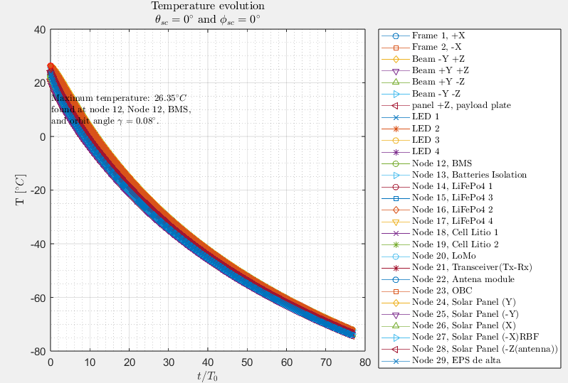
As expected, the temperature dropped due to radiation emission, at a rate that slowed down as the satellite cooled as expected given the non-linear relation between temperature and heat dissipation.
This is consistent with theory.

Heating And stationary regime
The satellite’s LEDs were turned on permanently in a cold void environment. The total heat generated was 12 W.
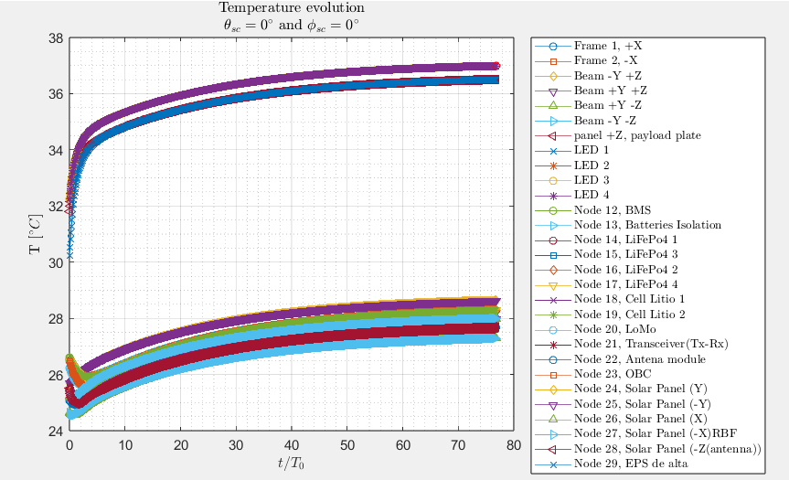

Stationary tendency
The temperatures fluctuate before asymptotically approaching some fixed values. This is expected of a transition into stationary regime, approaching the values at which the generated heat is the same as the radiated heat.
This is consistent with theory

Internal conduction
Inspecting the temperatures closer with the plot browser tool, we can identify that reached stationary regime the temperatures align such that they increase as the components get closer to the heat generating elements (The LEDs) with the LEDs being at the highest temperature. This is consistent with theory as the heat flows from higher to lower temperature.
We can see that the nodes separate into two groups, with the nodes integrated into the payload plate at considerably higher temperatures than the rest of the satellite. This indicates that the conductance between the payload plate and the rest of the satellite is considerably low.
Regardless this behaviour is consistent with theory.

solar cycle and albedo
With the satellite off, we simulate the sun radiation and albedo from earth.
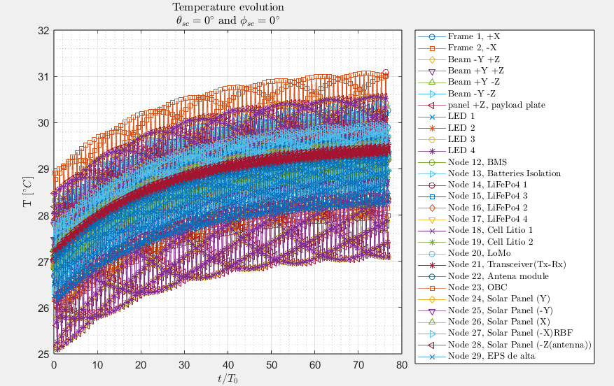

Equilibrium tendency
We can observe how the satellite’s overall temperature increases asymptotically approaching equilibrium with the environment, when the energy radiated per solar cycle equals the energy absorbed.
This is consistent with theory.

Temperature fluctuations
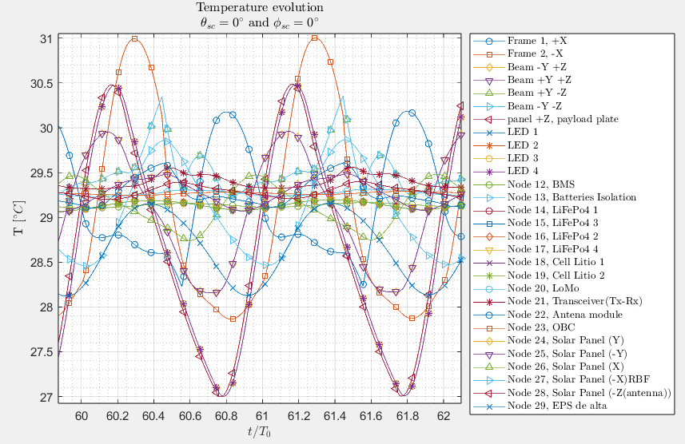
A closer inspection with the plot browser tool reveals that those nodes closer to the surface (Solar panels, rails, beams…) fluctuate with higher amplitude than those closer to the centre (Batteries, computers…). This is expected as the surface nodes are more exposed to the sun, as well as being the ones that radiate the heat.
This is consistent with theory.

Cuantitative tests
These tests are performed to fully check the correct functioning of the thermal mathematical model at a much precise level. The numerical results are evaluated and therefore external data is required to be compared to said results. These data could come from either analytical calculations or other simulation software.

Stationary regime
The nodes temperatures approaching stationary regime were compared to those provided by [Daniela’s TFG].

Comparaison data characteristics
The results from [Daniels’s TFG] were obtained computationally on excel. An analytical model of the satellite on stationary regime was built on which the excel solver tool found the heat generation or dissipation on each node required to meet a given temperature criterion. This in turn provides the resulting temperatures, allowing for instant analytical validation of the results.
However, this model lacks some of the internal nodes such as batteries and computers. But since these nodes are internal and won’t heavily influence the conductance’s nor radiation surface, the results from both models should approach.
A max temperature of 105ºC for the LED’s was chosen as the restriction, and an environment temperature of 60ºC was selected. Since our aim is to check the correct functioning of our model, we wont focus on the practical validity of these assumptions.
The following results are obtained from [Daniela’s TFG]:
(EVERYTHING HERE ONWARDS IS WRONG)
Node | Temperature | Heat generation
'Frame 1, +X' | 85,95 | -1,63
'Frame 2, -X' | 85,95 | -1,63
'Beam -Y +Z' | 87,57 | -0,18
'Beam +Y +Z' | 87,57 | -0,18
'Beam +Y -Z' | 84,29 | -0,14
'Beam -Y -Z' | 84,29 | -0,14
'panel +Z, payload plate ' | 104,26 | -1,71
'LED 1 ' | 105,00 | 4,19
'LED 2' | 105,00 | 4,19
'LED 3' | 105,00 | 4,19
'LED 4 ' | 105,00 | 4,19
'Node 24, Solar Panel (Y)' | 78,37 | -2,78
'Node 25, Solar Panel (-Y)' | 78,37 | -2,78
Node 26, Solar Panel (X)RBF' | 78,37 | -2,78
Node 27, Solar Panel (-X)' | 78,37 | -2,78

Comparaison and results
The satellite was turned on permanently with a total heat generation of 18,08W, the environment was a warm void at 22ºC.
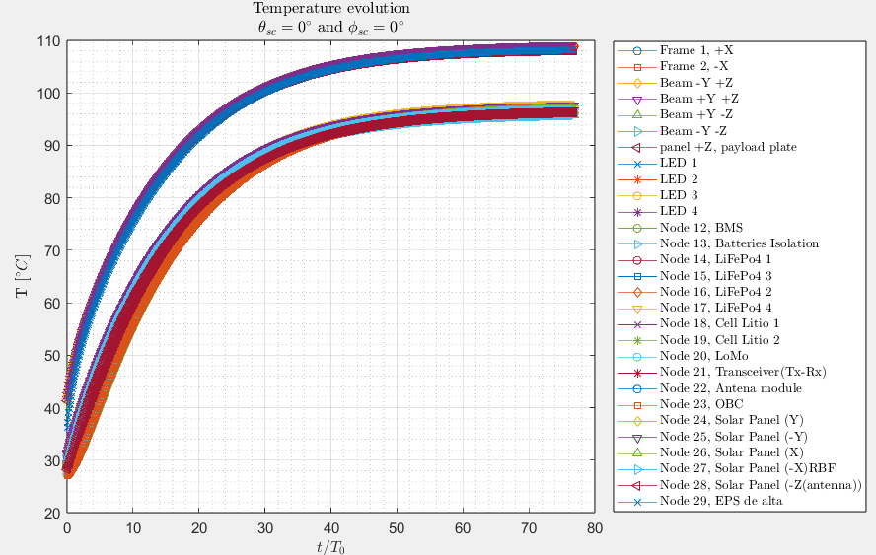
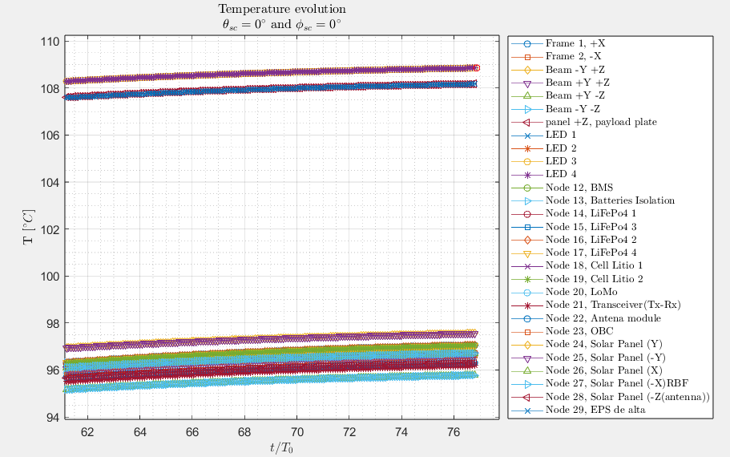
Again, we observe a transition to stationary regime.

The following results are extracted from the last t value calculated:
 | Node | Temperature | Heat
1 | Frame 1+X | 96,72 | 2,6000
2 | Frame 2 -X | 96,72 | 2,6000
3 | Beam -Y +Z | 97,56 | 1,0663
4 | Beam +Y +Z | 97,56 | 1,0663
5 | Beam +Y - Z | 95,78 | 1,0319
6 | Beam -Y -Z | 95,78 | 1,0319
7 | Payload plate (panel +Z) | 108,18 | 5,8581
8 | LED 1 | 108,85 | 0,3554
9 | LED 2 | 108,85 | 0,3554
10 | LED 3 | 108,85 | 0,3554
11 | LED 4 | 108,85 | 0,3554
12 | BMS | 97,04 | 0,0000
13 | Batteries insulation | 97,05 | 0,0000
14 | LiFePO4 1 | 97,05 | 0,0000
15 | LiFePO4 2 | 97,05 | 0,0000
16 | LiFePO4 3 | 97,05 | 0,0000
17 | LiFePO4 4 | 97,05 | 0,0000
18 | Cell Li 1 | 97,05 | 0,0000
19 | Cell Li 2 | 97,05 | 0,0000
20 | Lomo | 96,61 | 0,0000
21 | Transceiver | 96,19 | 0,0000
22 | Antenna module | 96,31 | 0,0000
23 | OBC | 96,60 | 0,0000
24 | Solar Panel Y | 96,66 | 0,0000
25 | Solar Panel -Y | 96,66 | 0,0000
26 | Solar Panel X | 96,71 | 0,0000
27 | Solar Panel -X | 96,71 | 0,0000
28 | Solar Panel -Z | 96,30 | 0,0000
29 | EPS Alta | 108,17 | 0,0000

